|  |
| --- |
| MAMUN’S GAME STUDIO |
| **FIGHT FOR COLORS** |
| A RETRO SHOOTER GAME |
| Version #01  All work Copyright © 2012 by MAMUN’S GAME STUDIO.  All rights reserved. |
| **MD MAMUNUR RAHMAN** |
|  |



|  |
| --- |
| **September 27th 2016** |

**Table of Contents**

[Your Table of Contents should go here. Make sure that your document’s sections are hyperlinked to their corresponding pages.]

**Version History**

GitHub Link: <https://github.com/300872772/COMP305-F2016-Assignment1>

1. **Game Overview**

‘Fight For Colors’ is a simple retro side-scrolling shooter game. The player’s space ship is limited to the bottom portion of the screen. The background colourful world graphic scrolls in top-down direction. The player must avoid killer Relic and grab power Relic while moves through the color world.

1. **Game Play Mechanics**

(how does your game work?)

1. **Camera**

The camera for this game uses an orthographic projection from a top-down (birds eye) view.

1. **Controls**

The control of this game is with the mouse only. The mouse allows the player to move left to right across the bottom of the screen.

1. **Interface Sketch**

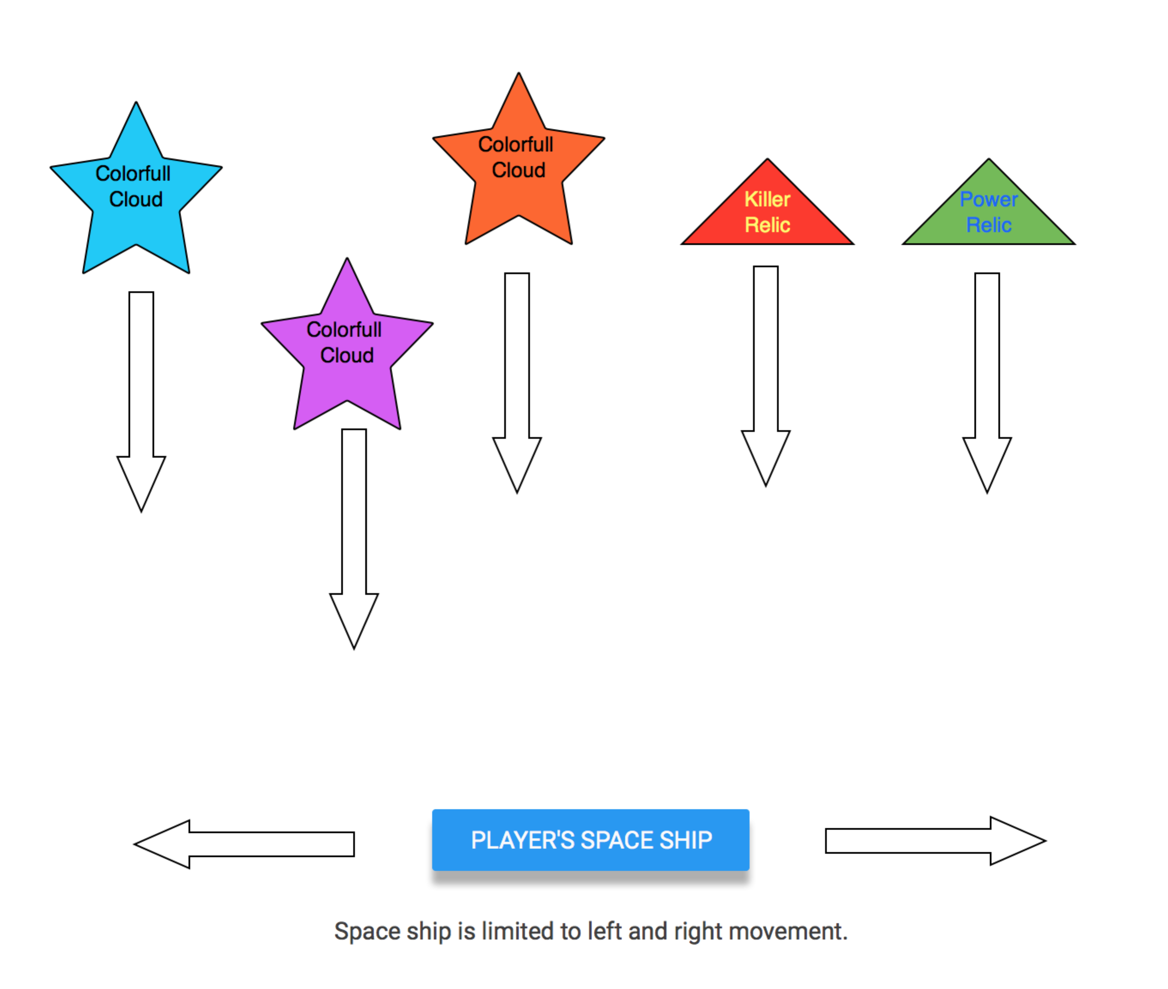

1. **Menu and Screen Descriptions**

*(Include additional screen shots and accompanying descriptions for any menus and additional screen)*

1. **Characters**

*The player’s avatar is a simple colourful space ship that seems to fly over a scrolling colourful world. The player’s movement is limited (right to left only) to increase the challenge level of the game.*

1. **Enemies**

*The enimies of this game are killer Relics that the player must avoid. Besides, there is enimy space ship to kill players. We will add animated lightening if time allows.*

1. **Items**

*The player’s main pickup is power Relic and killing eminy ships to gain points.*

1. **Scoring**

*The player score points when grab power Relic and kills enemy space ship. Each power Relic gives 100 points and killing each enemy space ship gives 50 points. The player starts with 5 lives. Each killier Relic grabing or 3 enemy shooting hits makes one life down.*

1. **Sound Index**

*(Include an index of all your sound clips)*

**----Excel sheet screen shot**

1. **Story Index**

*A planet inside colorful Andromind galaxy has been covered by black power and Avatar has got mission to fight against black power to rescucue colorful world. This is the story of Fight for Colors, colors of life.*

1. **Art / Multimedia Index**

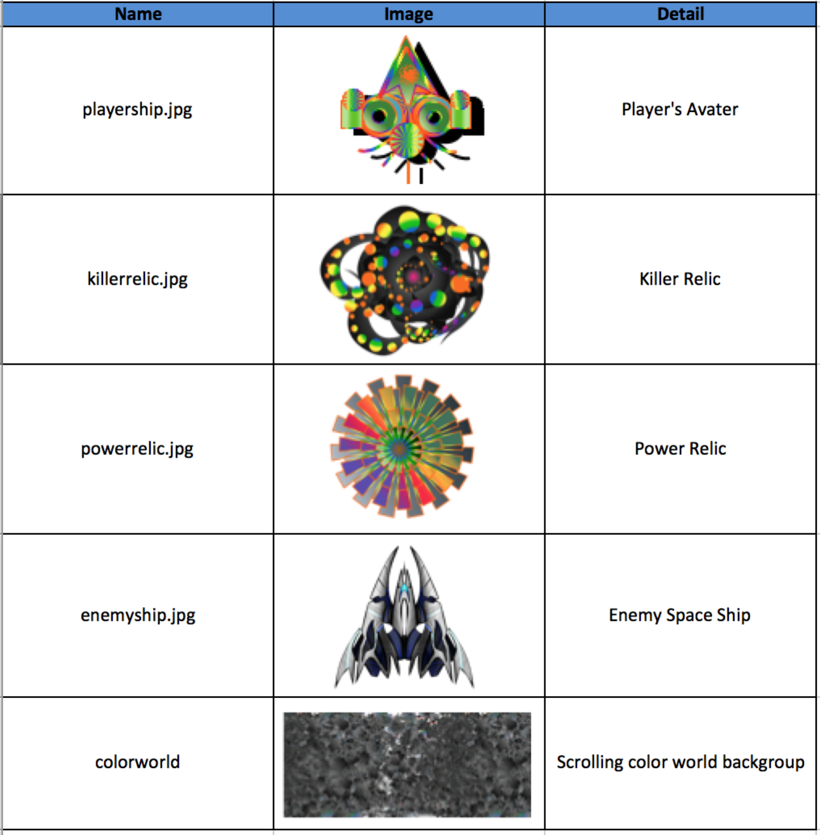

1. **Design Notes**

*(Include additional design notes here)*

1. **Future Features**

*(Include any future features that are planned to be implemented)*